Directions to 7245 Clinton Road

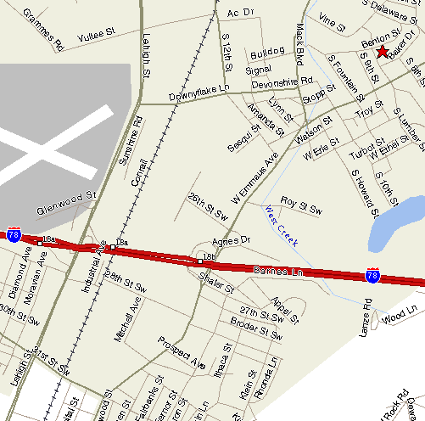

From the South:

Drive West into Allentown on US RT 78.
Exit at Lehigh Street North (exit 57)
Make left at light after exit ramp turning north onto Lehigh Street
See final directions below

From the East:

Drive East into Allentown on US RT 78.
Exit at Lehigh Street North (exit 57)
Merge right after exit ramp turning north onto Lehigh Street
See final directions below

Final Directions:

Turn right at 1st or 2nd light onto Downyflake Road (Blockbuster on corner)
Drive thru one light. At 2nd light, turn right onto Mack Boulevard
At next light, turn left onto Emmaus Avenue
Travel ≈ 3 blocks, turn left onto South Lumber Street (between 8th and 9th Streets)
House is 1.5 blocks ahead on the right
Look for elegant two-story traditional brick home with slate accents

