Directions to 710 North 12th Street

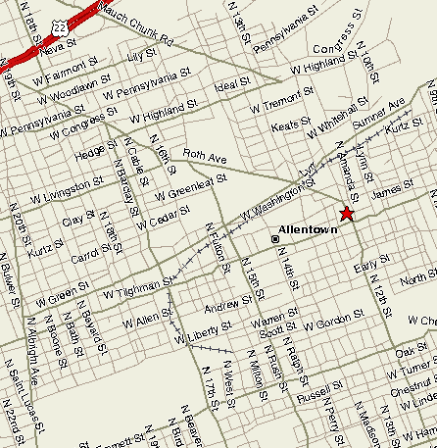

From the North:

Drive West into Allentown on US RT 22.
Exit at 15th Street
Make right at light after exit ramp turning south onto 15th Street
Drive thru approximately 3 lights
Make left at light onto Tilghman Street
Follow Tilghman until making a left onto 12th Street (at a light)
House is 5th house on the left

From the South:

Drive East into Allentown on US RT 78.
Exit at Lehigh Street North (exit 57)
Merge left after exit ramp turning north onto Lehigh Street
Turn left at ≈ 4th light (following signs for 15th Street)
Continue on 15th Street for about 5 lights.
Make right at light onto Tilghman Street
Follow Tilghman until making a left onto 12th Street (at a light)
House is 5th house on the left

