Directions to 5 Oakland Avenue

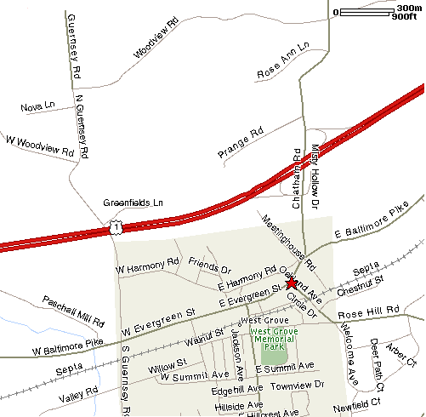

From the North:

Drive South on US RT 1.
Exit at PA RT 841 exit toward West Grove
Make left after exit ramp onto Chatham Road / RT 841
See final directions below

From the South:

Drive North on US RT 1.
Exit at PA RT 841 exit toward West Grove
Merge right after exit ramp onto Chatham Road / RT 841
See final directions below

Final Directions:

Continue on RT 841 for ½ miles
Turn right onto Old Baltimore Pike
Turn left onto Oakland Avenue (first left after passing a gas station)
House is second from the corner on the left side
Look for elegant two-story brick home with large front porch

