Directions to 130 80th Street East

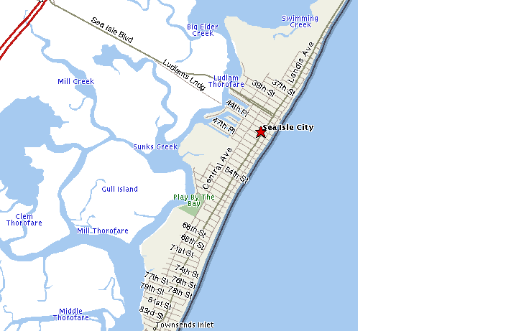

From the Chester County:

Drive north on the North East Extension PA RT 476
Take exit for Lehigh Valley (exit 33)
Make a right onto US RT 22 East towards Allentown
Take first exit towards RT 309 South towards Quakertown

From the Allentown:

Drive East into Allentown on US RT 78.
Exit at Lehigh Street North (exit 57)
Merge right after exit ramp turning north onto Lehigh Street
See final directions below

Final Directions:

Turn right at 1st or 2nd light onto Downyflake Road (Blockbuster on corner)
Drive thru one light. At 2nd light, turn right onto Mack Boulevard
At next light, turn left onto Emmaus Avenue
Travel ≈ 3 blocks, turn left onto South Lumber Street (between 8th and 9th Streets)
House is 1.5 blocks ahead on the right
Look for elegant two-story traditional brick home with slate accents

